1. Click “Tools” Tab and next Click “Connect to Database”. See below image.

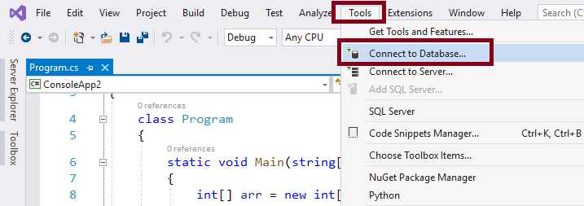

2.Choose “Microsoft SQL Server” from Data source and click “Continue” button. see below image.

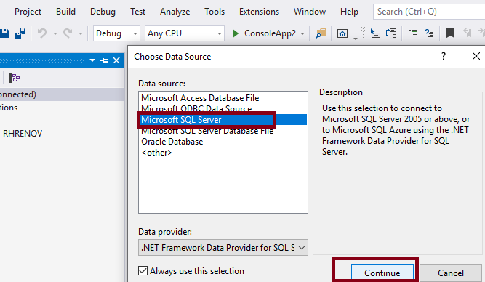

3. Give Microsoft SQL Server name, you can select Windows Authentication or you can give SQL Server Authentication. Enter User name and Password. Select or enter a database name from drop down box. Click “Test Connection” button. if connection succeeded then click OK. Follow below image.

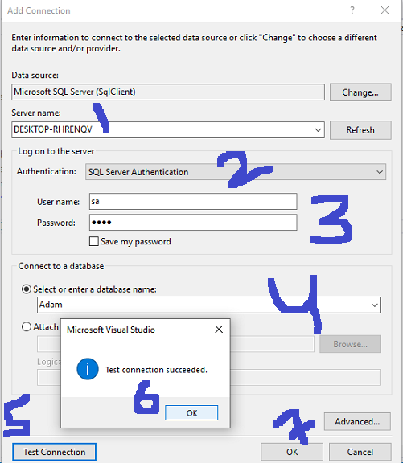

4. After Clicking OK button, you can see SQL Server successfully connected with Visual Studio. you can see in below image. Now you can use the connection in Any Code.

